Configuring Navigator Users

Set-up and Security
Access to Navigator applications can be granted or restricted globally, by authority class, or by user.
Global settings (NAV 2) are the initial settings, Authority Class settings (NAV1) override the global settings, and User settings (NAV 5) override both global and authority class settings.

Navigator Menu
The Navigator menu provides options to secure data and limit user access to the Navigator web-based applications.
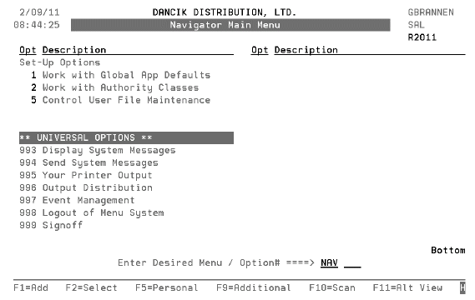
Note: If changes or updates are made on the Navigator menu, the web browser must be completely closed down and then reopened for the changes to be reflected on the web portions of Navigator.

Work with Global App Defaults - NAV 1
This option allows you to establish global settings for the Navigator applications.
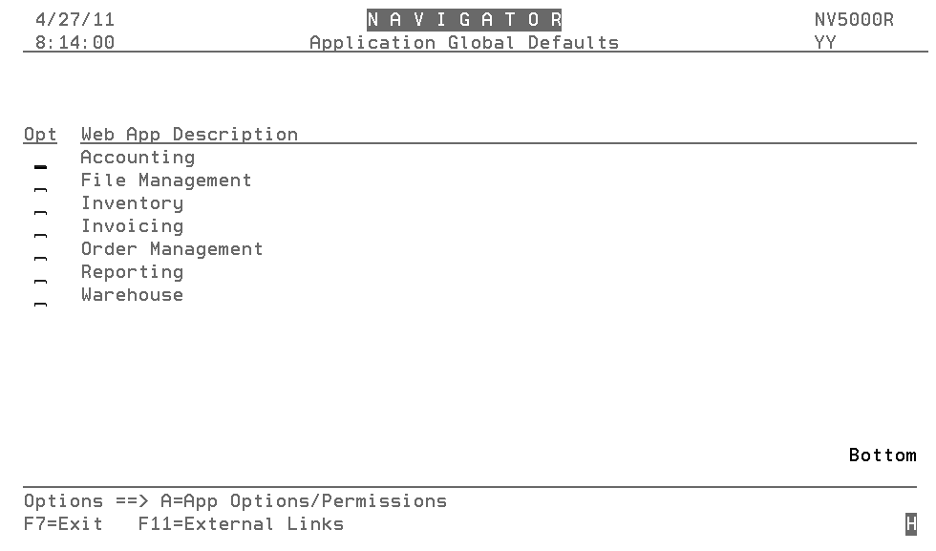
Note: The F11=External Links function allows you to add websites to the Navigator application. For more information refer to Adding External Links.
Each of the applications has its own options and permissions.

Accounting
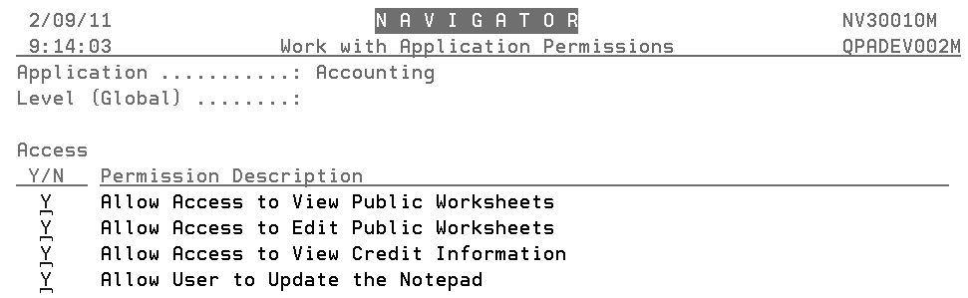

File Maintenance
This option provides a method to secure features and files on the web based File Management application.
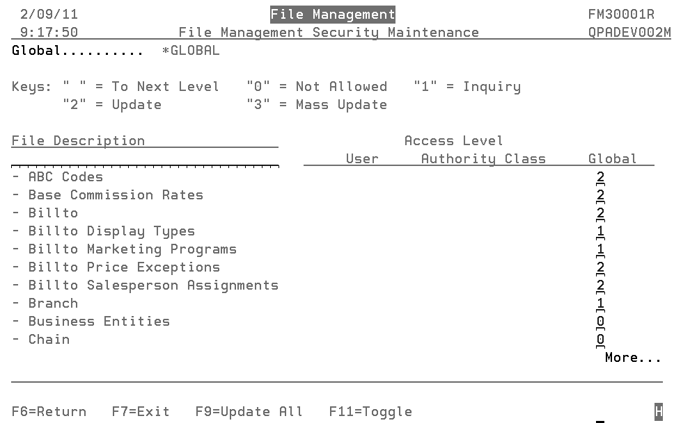
Each user has three access levels:
- User - Overrides the Authority Class and Global settings. User settings are established via menu option NAV 5 option “W”.
- Authority Class - Overrides the Global settings. Authority Class settings are established via menu option NAV 2.
- Global - Applies to all users unless overridden.
The following security/access levels are available:
- Blank - Uses the setting from the next level, which for global settings is authority class.
- 0 - Not allowed. This setting might be used for files that display cost and pricing information. Files assigned a “0” will not display on the application unless the user or authority class overrides the global setting.
- 1 - Allows an inquiry into the file.
- 2 - Allows for updates and changes to a file.
- 3 - Gives mass update capability. This feature enables you to update multiple records at one time. This is a very powerful and potentially dangerous option.
1. Press F11 to mange the filters available to the user.
Note: The File Management Navigator application uses filters to narrow the search results. For example, you can limit Billto Accounts displayed to your best customers by using the ABC codes.
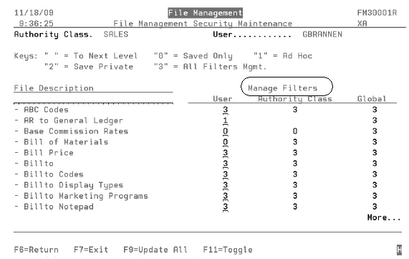
2. The available settings are:
- 0 - Saved filters - No buttons to save, manage, or reset. User can only work with filters that are available via the dropdown.
- 1 - Ad Hoc - Ability to create filters on the fly. Cannot save newly created filters. User can work with filters that are available via the dropdown.
- 2 - Save Private - Save and manage filters for yourself. No public option available - Only private.
- 3 - All Filter Mgmt - All Public/Private filters available. Can only manage “your” private/public filters.
The following graphics show how these settings affect the File Management Web Application Filter tab.
File Management Filter tab (accessed by clicking the Filters)
Save Filter Dialog Box (accessed by clicking the Save button)
- Options 0 and 1 cannot access this feature.
- Option 2 only allows a user to save private filters. The public option does not display.
- Option 3 - both options display.
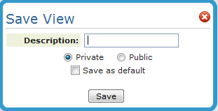
3. Press F11 to toggle the settings to Download capability.
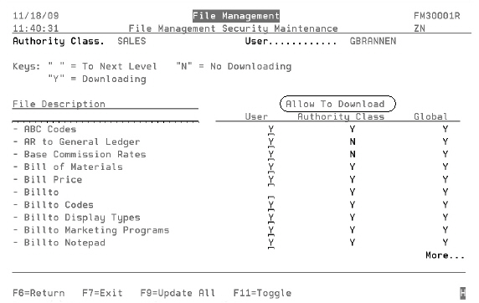
This capability grants or denies the user the ability to download reports as Excel spreadsheets on a file-by-file basis. You can allow a user to run a report of ABC codes, but then deny them the ability to run a report that displays costs.
If downloading ability is granted, the Excel spreadsheet icon displays on the file.

Mass Update
The F9=Update All function allows you to make all the settings at one time.
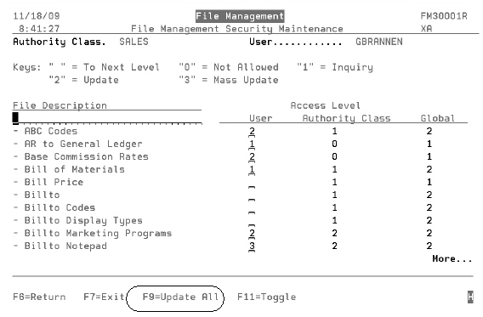
This option is a good way to set up new users with a baseline of settings. The settings can then be individually tweaked as needed.
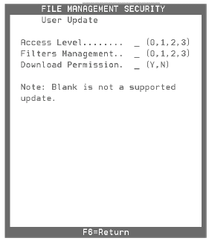
Enter the appropriate setting level for each of the three functions. If a field is left blank, the system does not change or update anything (i.e. it does not make all the settings blank).

Adding External Links
Use the F11-External Links function to add website addresses to the Links tab.
Note: The web links added here are global and will be available to all Navigator users. To limit websites to specific users, use Authority Classes (NAV 2).
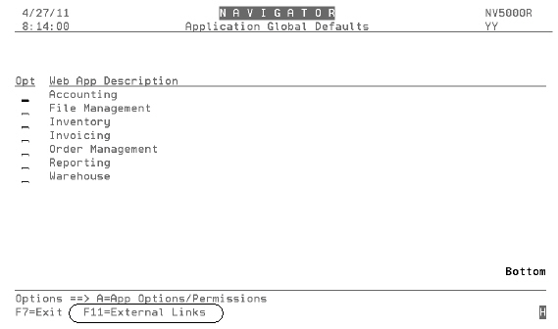
Press F11 to access the initial screen.
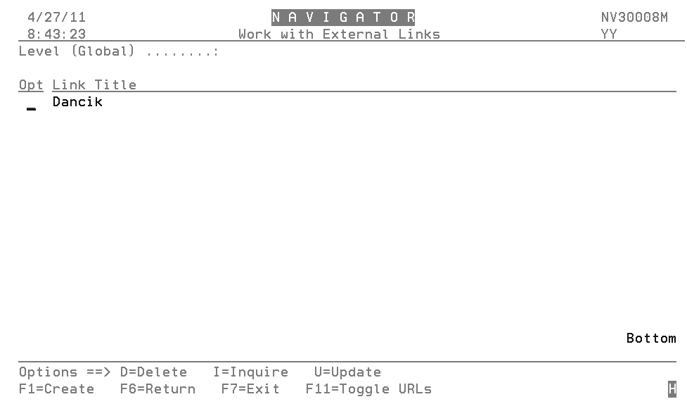
Press F1 to create a new link.
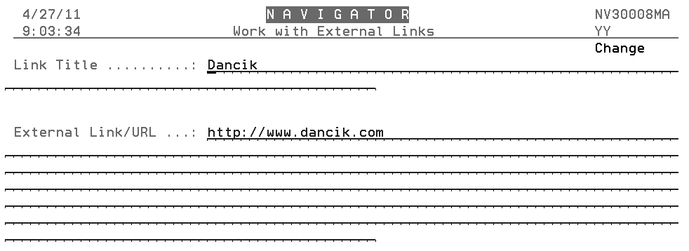
The entire Link/URL must be used; including the protocol (http for most websites).
The entered websites are accessed via the Links tab within Navigator.
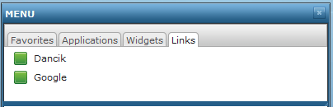

Work w/ Authority Classes
Authority classes allow you to group users together; they can be created based on system access restrictions or on a user's functional areas such as AP clerk, order clerk, or customer service. They allow you to customize the level of access a group of users has within Navigator.
A user must be assigned to an authority class before access to the application(s) is granted. However, a user can still be granted access to a specific application at the user level even if access to an authority class has been revoked.
1. When this option is accessed, the existing authority classes appear.
Note: Use F1 to create new Authority Classes.
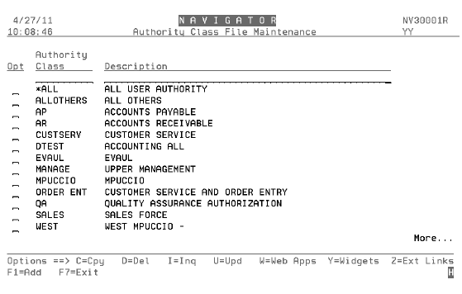

Options
W=Web Apps
Y=Widgets
Z=Ext Links
W=Web Apps
1. To grant or deny access to an authority class, enter a W (Work w/ Web Apps) in the appropriate Opt field.
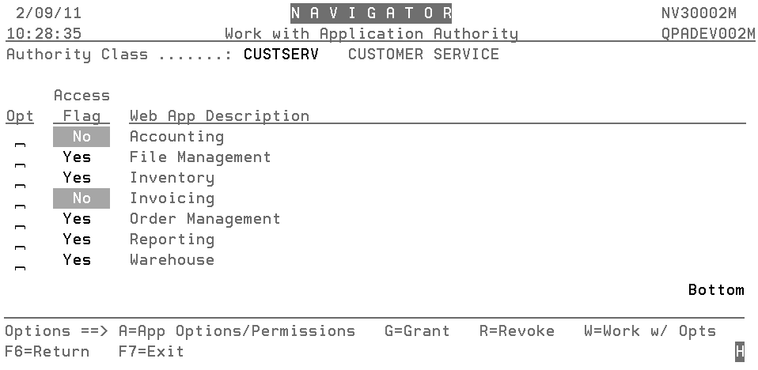
2. To expand the web application to grant access to individual features, use option A=Application Options.
The functionality for establishing access and security by authority class is the same as when doing it at the global level. Just remember the hierarchy, user settings override, authority class settings, and authority class settings override global settings.
Y=Widgets
Use these tools to quickly and easily find specific information.
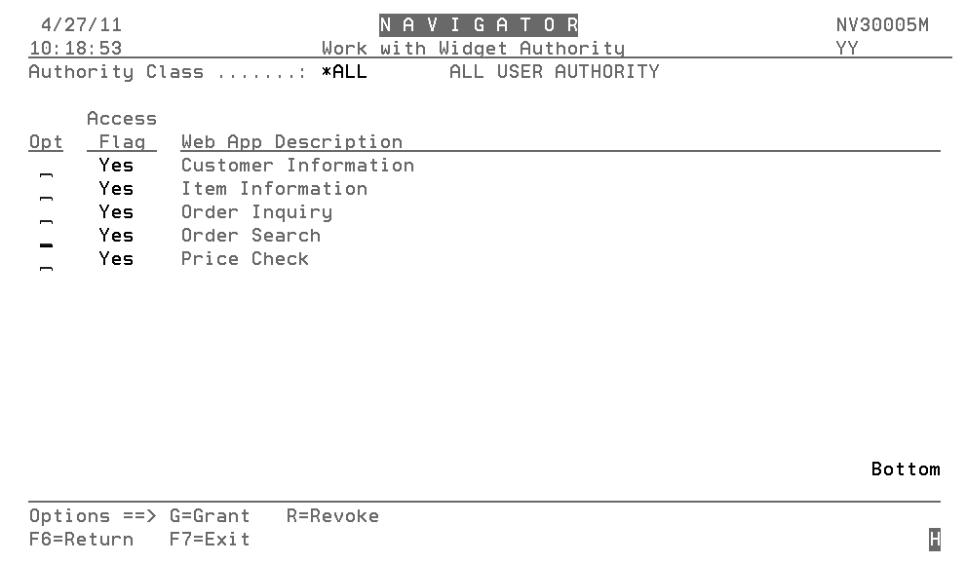
- Customer Information - Enter a full or partial customer name. Navigator searches through the Billto File to collect customer information sales statistics. It searches the Accounts Receivable files for the customer’s AR History.
- Item Information - Enter a complete or partial item number. You can also search on an item’s attributes such as “red” or “12 x 12”. Both lines of the item description are searched on. Navigator searches the Inventory application to access sales statistics, item details, and current and future inventory (purchase orders and back orders.
- Order Search - Search for processed or unprocessed orders using a variety of parameters such as item number, salesman, or job name. Order details can be viewed on screen by clicking either the order number or reference number.
- Order Inquiry - This widget provides a “Inquiry” only view into orders. You cannot update the order, but you can access information about the order such as customer information, delivery and pick-up times, and if miscellaneous charges are applied.
- Price Check - Item prices can vary by account number and by item type. For example, roll items can use either roll or cut pricing. If you do not enter a quantity, a quantity of 1 is assumed. If you do not enter a UM, the native unit of measure, as created in the Item File, is used as the default.

Z=Ext Links
Use this option to add links to external webpages. Links can also be added at the global level. For detailed information, refer to Adding External Links.

Control User File Maintenance - NAV 5
This user administration program combines all of the user-related settings into one place. It combines all of the user defaults, security fields, and parameters related to any application, including web applications like IWMS, Selection Sheet Manager, and File Management.
User settings are the top level settings. They override the authority class and global settings.
NAV 5 contains the following options:
- C - Copy one user's settings to another.
- D - Delete a user's settings.
- I - Inquire - View a user's settings.
- U - Update a user's settings. There are three screens of settings that allow or deny a user access to perform operations such as:
— see costs
— adjust inventory
— enter orders
— access the Order Change and Cancel programs
— access the Update Order Status & Shipping Data program
— Billto/Shipto file updates
Note: The settings listed above are a very small portion of the settings available. For a complete listing, to include detailed descriptions of each setting, refer to the System Administration Manual.
- W - Web Access- Enable or disable a user's access to the Dancik web applications, and enter settings, through the respective function key, applicable to each application.
Use the Navigator Authority Class field to assign the user to an established authority class.
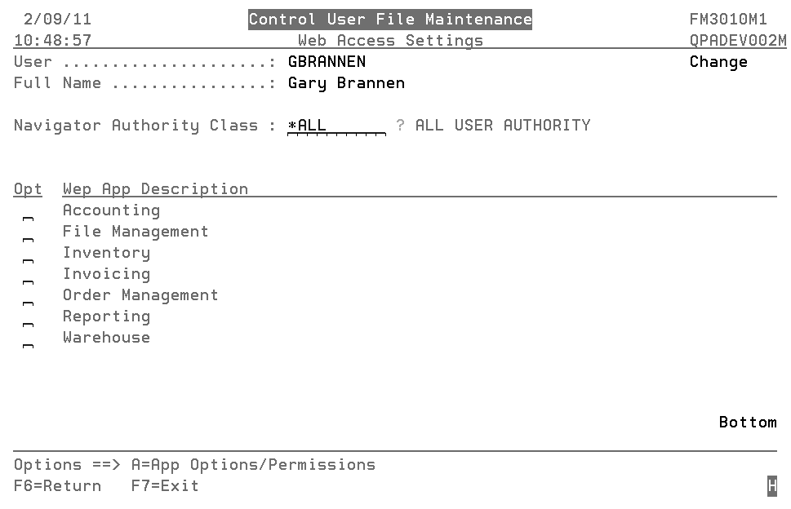
— Use the A=App Options/Parameters option to specify the access level for the features within a Navigator application. These settings are established in the same manner as the global settings so for more detailed information refer to “Work with Global App Defaults - NAV 1.
- Y - Web Control Panel - These settings are the same settings that establish operator defaults and restrictions based on the users work station ID. The difference is that these settings relate to a user ID instead of a workstation, and only affect the users use of Dancik's web based applications. Essentially these settings enable user-based web applications to use restrictions and settings normally associated with a work station.

